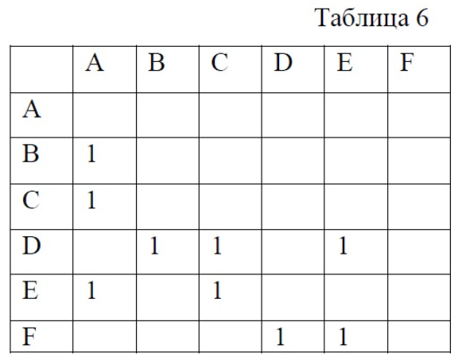

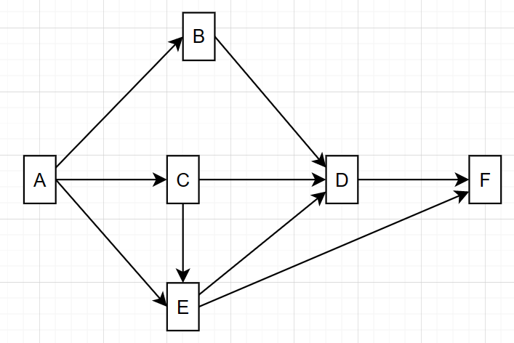

#include <iostream>

using namespace std;

class A

{public: void f() { cout << " A";}};

class B: public virtual A

{public: void f() { cout << " B";}};

class C: public virtual A

{public: void f() { cout << " C";}};

class E : public virtual A, public virtual C

{ public: void f() { cout << " E"; }};

class D : public virtual B, public virtual C, public virtual E

{public: void f() { cout << " D"; }};

class F: public virtual D, public virtual E

{ /\*public: void f() { cout << " F"; };\*/

};

int main()

{

F object;

object.f();

object.A::f();

object.B::f();

object.C::f();

object.D::f();

object.E::f();

}

